Azure Virtual Networks and Virtual Machines

3. Deploy a sample application in the VM and access using Public IP.

Step 1: Go to Azure portal <https://portal.azure.com>. Click on Ubuntu 18.04LTS.

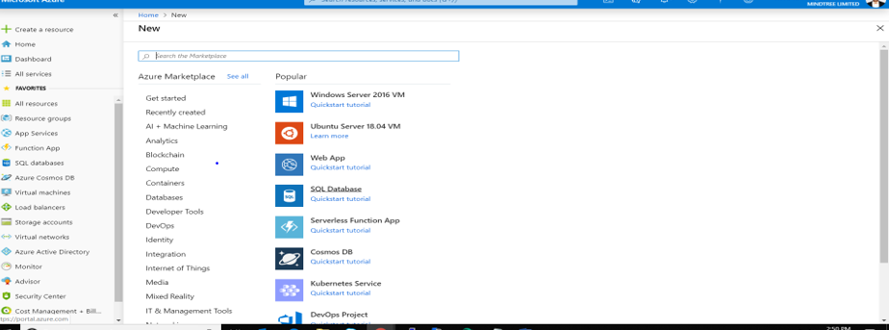

Step 2: Fill in the configuration details.

Step 3: Click on Review+ create. We get the following page as a result.

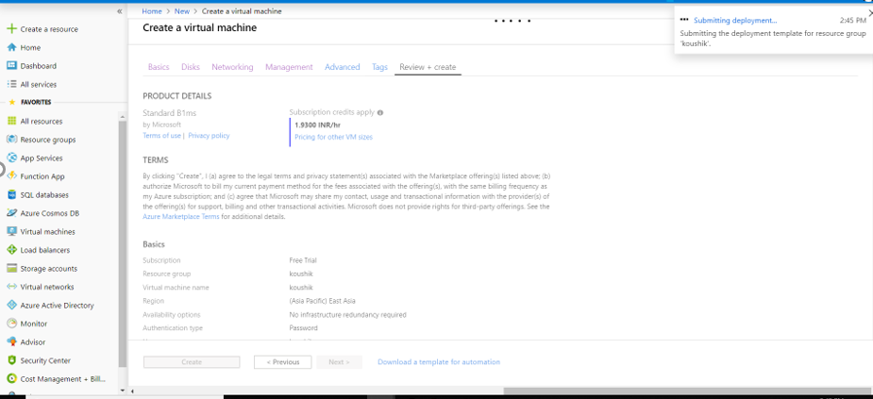

We get this page that the deployment is underway.

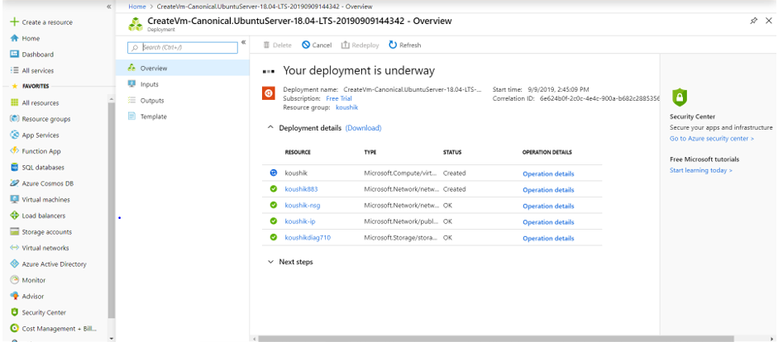

Once the deployment is complete, we get this page.

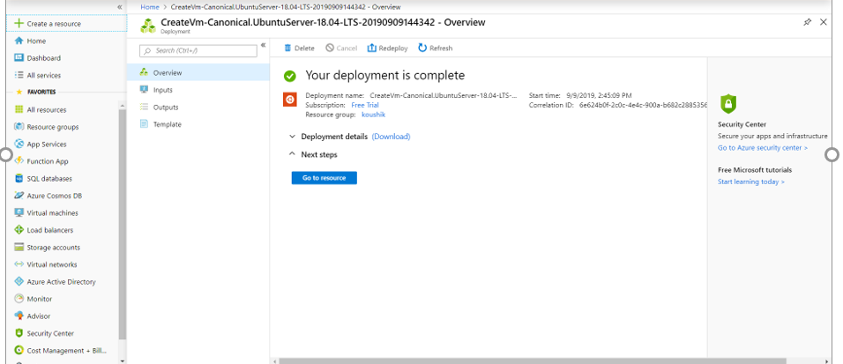

Step 4: Click on go to resource and open the VM.

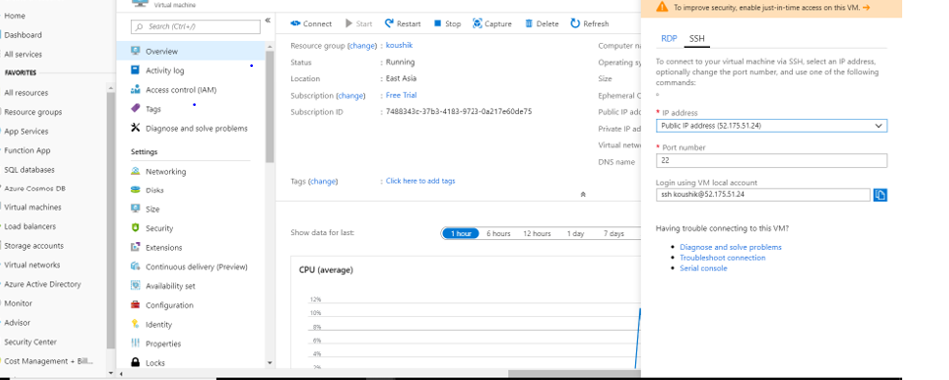

Now, using the IP address open the VM in putty.